ITA0515
Computer Vision Lab Programs (05 - 10)

Y. Jayesh Ranjan
192472201

EXP 11
Aim
To perform an affine transformation on an image using OpenCV.

Algorithm
- Import the OpenCV and NumPy libraries.
- Read the input image.
- Get the image dimensions.
- Create the affine transformation matrix.
- Apply the affine transformation.
- Display the original and transformed images.
- Save the transformed image.

Code
import cv2
import numpy as np
image = cv2.imread("image1.jpg") rows, cols = image.shape[:2]
M = np.float32([[1, 0, 100],
[0, 1, 50]])
affine = cv2.warpAffine(image, M, (cols, rows)) display_original = cv2.resize(image, (400, 300))
display_affine = cv2.resize(affine, (400, 300)) cv2.imshow("Original Image", display_original) cv2.imshow("Affine Transformed Image", display_affine) cv2.imwrite("affine_image.jpg", affine)
cv2.waitKey(0)

cv2.destroyAllWindows()

Input


Output
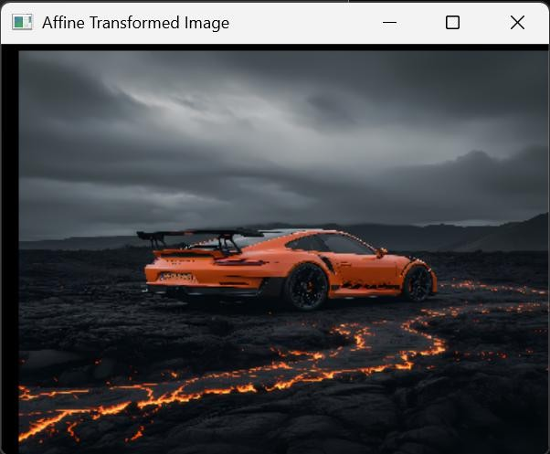

Result
Thus, the program to perform affine transformation on an image was executed successfully.

EXP 12

Aim
To perform perspective transformation on an image using OpenCV.

Algorithm
- Import the OpenCV and NumPy libraries.
- Read the input image.
- Select four source points.
- Select four destination points.
- Compute the perspective transformation matrix.
- Apply the perspective transformation.
- Display and save the transformed image.

Code
import cv2
import numpy as np

image = cv2.imread("image1.jpg")

rows, cols = image.shape[:2]

src_points = np.float32([ [0, 0],
[cols - 1, 0],
[0, rows - 1],
[cols - 1, rows - 1]
])

dst_points = np.float32([ [0, 0],
[cols - 1, 0],
[int(0.3 * cols), rows - 1],
[int(0.7 * cols), rows - 1]
])

matrix = cv2.getPerspectiveTransform(src_points, dst_points)

output = cv2.warpPerspective(image, matrix, (cols, rows))

display_original = cv2.resize(image, (400, 300))
display_output = cv2.resize(output, (400, 300))

cv2.imshow("Original Image", display_original) cv2.imshow("Perspective Image", display_output)

cv2.imwrite("perspective_image.jpg", output)

cv2.waitKey(0) cv2.destroyAllWindows()

Input


Output
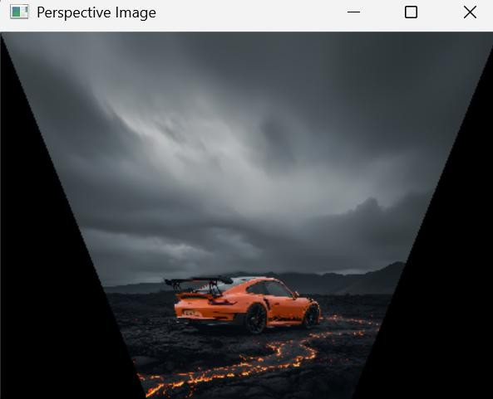

Result
Thus, the program to perform perspective transformation on an image was executed successfully.

EXP 13

Aim
To perform perspective transformation on live video using OpenCV.

Algorithm
- Import the OpenCV and NumPy libraries.
- Open the webcam.
- Define source and destination points.
- Compute the perspective transformation matrix.
- Read video frames.
- Apply the perspective transformation.
- Display the original and transformed video.
- Press Q to exit.

Code
import cv2
import numpy as np
src = np.float32([[100, 100], [500, 100], [100, 400], [500, 400]])
dst = np.float32([[0, 0], [400, 0], [0, 400], [400, 400]])
matrix = cv2.getPerspectiveTransform(src, dst) cap = cv2.VideoCapture("sample.mp4")
while True:
ret, frame = cap.read() if not ret:
break
transformed = cv2.warpPerspective(frame, matrix, (400, 400)) cv2.imshow("Original Video", frame)

cv2.imshow("Perspective Video", transformed) if cv2.waitKey(30) & 0xFF == ord('q'):
break cap.release()
cv2.destroyAllWindows()

Input
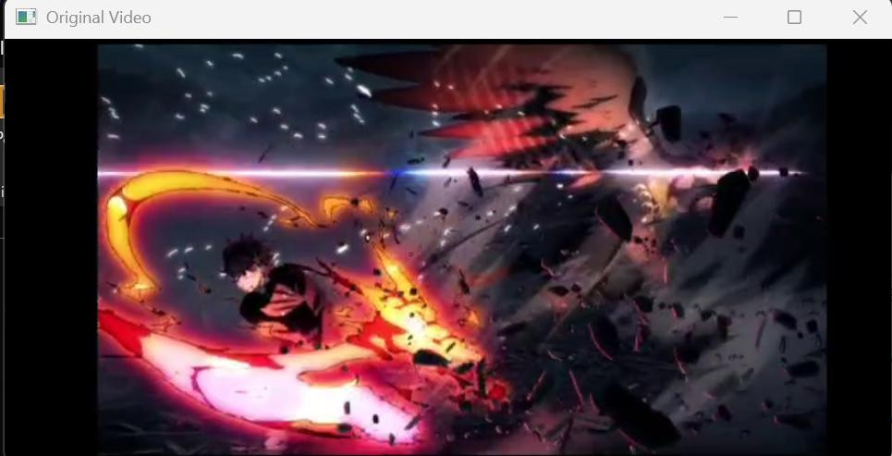

Output
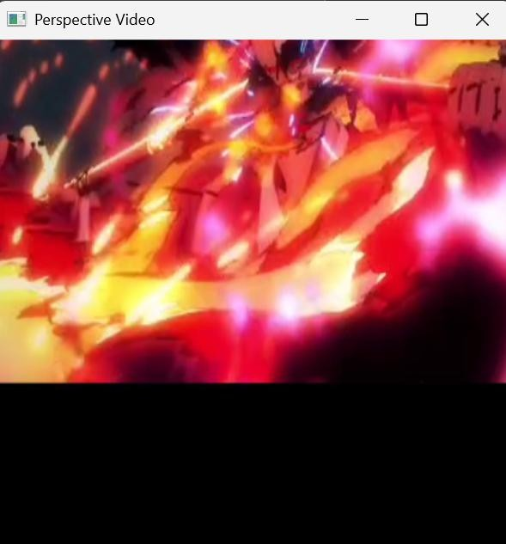

Result
Thus, the program to perform perspective transformation on a video was executed successfully.

EXP 14

Aim
To perform transformation using a Homography Matrix on an image.

Algorithm
- Import the OpenCV and NumPy libraries.
- Read the input image.
- Define source and destination points.
- Find the Homography Matrix.
- Apply the transformation.
- Display the original and transformed images.
- Save the transformed image.

Code
import cv2
import numpy as np
image = cv2.imread("image1.jpg") rows, cols = image.shape[:2] src_points = np.float32([
[0, 0],
[cols - 1, 0],
[0, rows - 1],
[cols - 1, rows - 1]
])
dst_points = np.float32([ [0, 0],
[cols - 1, 0],

[0, int(0.7 * rows)],
[cols - 1, int(0.7 * rows)]
])
H, _ = cv2.findHomography(src_points, dst_points) output = cv2.warpPerspective(image, H, (cols, rows)) display_original = cv2.resize(image, (400, 300))
display_output = cv2.resize(output, (400, 300)) cv2.imshow("Original Image", display_original) cv2.imshow("Homography Image", display_output) cv2.imwrite("homography_image.jpg", output) cv2.waitKey(0)
cv2.destroyAllWindows() Input
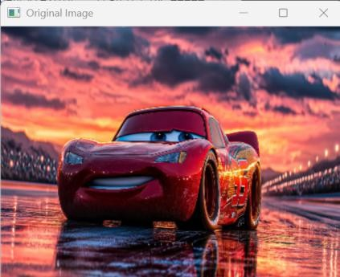
Output


Result
Thus, the program to perform image transformation using the Homography Matrix was executed successfully.

EXP15

Aim
To perform Direct Linear Transformation (DLT) on an image using OpenCV.

Algorithm
- Import the OpenCV and NumPy libraries.
- Read the input image.
- Define source and destination points.
- Find the perspective transformation matrix.
- Apply the transformation.
- Display the original and transformed images.
- Save the transformed image.

Code
import cv2
import numpy as np
image = cv2.imread("image1.jpg") rows, cols = image.shape[:2] src_points = np.float32([
[0, 0],
[cols - 1, 0],
[0, rows - 1],
[cols - 1, rows - 1]
])
dst_points = np.float32([ [50, 50],
[cols - 50, 30],

[30, rows - 50],
[cols - 30, rows - 30]
])
matrix = cv2.getPerspectiveTransform(src_points, dst_points) output = cv2.warpPerspective(image, matrix, (cols, rows)) display_original = cv2.resize(image, (400, 300))
display_output = cv2.resize(output, (400, 300)) cv2.imshow("Original Image", display_original) cv2.imshow("DLT Image", display_output) cv2.imwrite("dlt_image.jpg", output) cv2.waitKey(0)
cv2.destroyAllWindows()

Input


Output
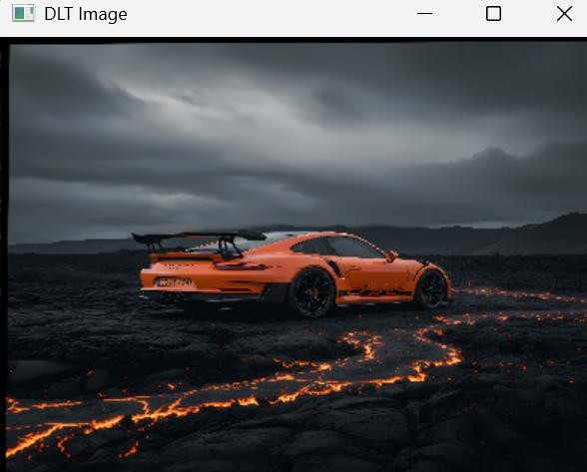

Result
Thus, the program to perform Direct Linear Transformation (DLT) on an image was executed successfully.

EXP 16

Aim
To perform edge detection on an image using the Canny edge detection method.

Algorithm
- Import the OpenCV library.
- Read the input image in grayscale.
- Apply the Canny edge detection method.
- Display the original and edge-detected images.
- Save the output image.

Code
import cv2
image = cv2.imread("image1.jpg", 0) edges = cv2.Canny(image, 100, 200)
display_original = cv2.resize(image, (400, 300))
display_edges = cv2.resize(edges, (400, 300)) cv2.imshow("Original Image", display_original) cv2.imshow("Canny Edge Detection", display_edges) cv2.imwrite("edges.jpg", edges)
cv2.waitKey(0) cv2.destroyAllWindows()

Input
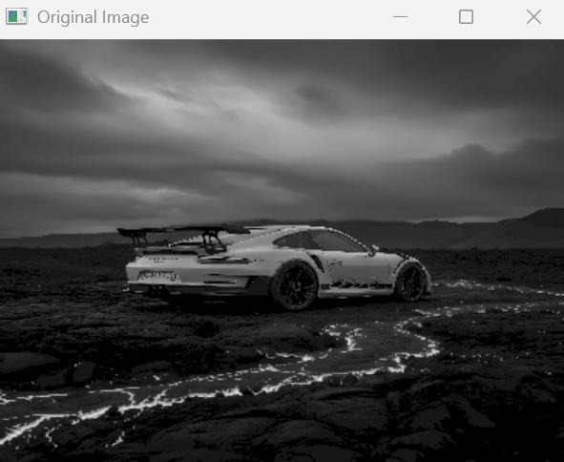

Output
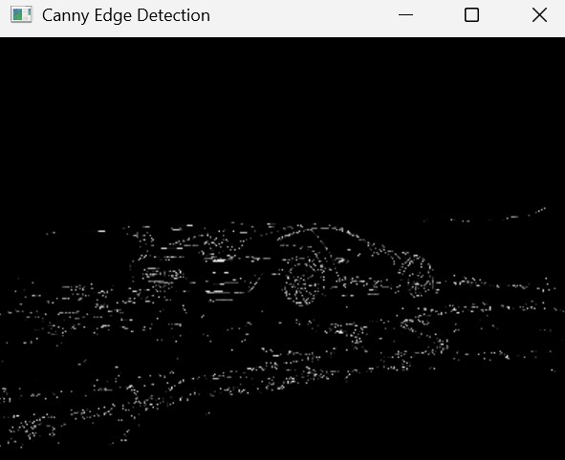

Result
Thus, the program to perform edge detection using the Canny method was executed successfully.

EXP 17

Aim
To perform edge detection on an image using the Sobel operator along the X-axis.

Algorithm
- Import the OpenCV library.
- Read the input image in grayscale.
- Apply the Sobel operator along the X-axis.
- Display the original and edge-detected images.
- Save the output image.

Code

import cv2

image = cv2.imread("image1.jpg", 0)

sobel_x = cv2.Sobel(image, cv2.CV_8U, 1, 0, ksize=5)

display_original = cv2.resize(image, (400, 300))
display_sobel = cv2.resize(sobel_x, (400, 300))

cv2.imshow("Original Image", display_original) cv2.imshow("Sobel X", display_sobel)

cv2.imwrite("sobel_x.jpg", sobel_x)

cv2.waitKey(0) cv2.destroyAllWindows() Input
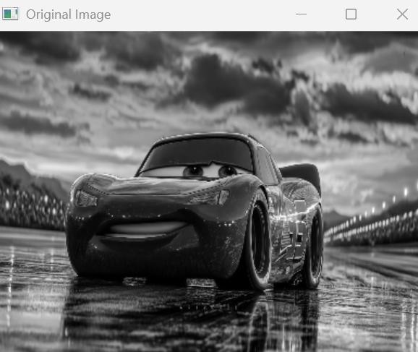

Output
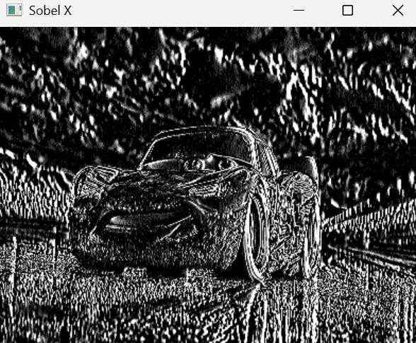

Result
Thus, the program to perform edge detection using the Sobel operator along the X-axis was executed successfully.

EXP 18

Aim
To perform edge detection on an image using the Sobel operator along the Y-axis.

Algorithm
- Import the OpenCV library.
- Read the input image in grayscale.
- Apply the Sobel operator along the Y-axis.
- Display the original and edge-detected images.
- Save the output image.

Code
import cv2

image = cv2.imread("image1.jpg", 0)

sobel_y = cv2.Sobel(image, cv2.CV_8U, 0, 1, ksize=5)

display_original = cv2.resize(image, (400, 300))
display_sobel = cv2.resize(sobel_y, (400, 300))

cv2.imshow("Original Image", display_original) cv2.imshow("Sobel Y", display_sobel)

cv2.imwrite("sobel_y.jpg", sobel_y)

cv2.waitKey(0)

cv2.destroyAllWindows()

Input
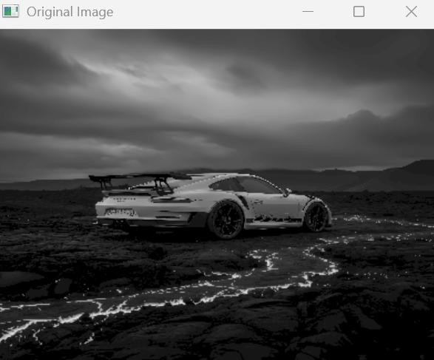

Output
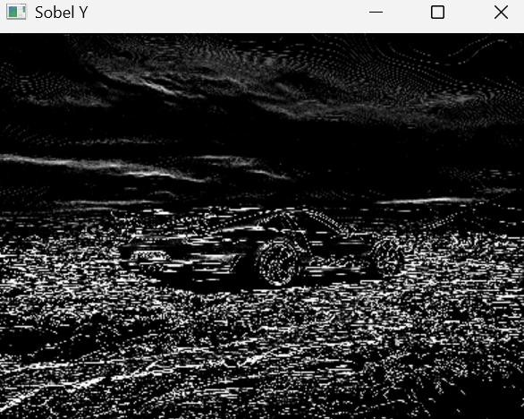

Result
Thus, the program to perform edge detection using the Sobel operator along the Y-axis was executed successfully.

EXP 19

Aim
To perform edge detection on an image using the Sobel operator along both X and Y axes.

Algorithm
- Import the OpenCV library.
- Read the input image in grayscale.
- Apply the Sobel operator along the X-axis.
- Apply the Sobel operator along the Y-axis.
- Combine both edge images.
- Display the original and combined edge image.
- Save the output image.

Code
import cv2
image = cv2.imread("image1.jpg", 0)
sobel_x = cv2.Sobel(image, cv2.CV_64F, 1, 0, ksize=3) sobel_y = cv2.Sobel(image, cv2.CV_64F, 0, 1, ksize=3) edges = cv2.addWeighted(sobel_x, 0.5, sobel_y, 0.5, 0) edges = cv2.convertScaleAbs(edges)
display_original = cv2.resize(image, (400, 300))
display_edges = cv2.resize(edges, (400, 300)) cv2.imshow("Original Image", display_original) cv2.imshow("Sobel XY", display_edges) cv2.imwrite("sobel_xy.jpg", edges) cv2.waitKey(0)
cv2.destroyAllWindows()

Input
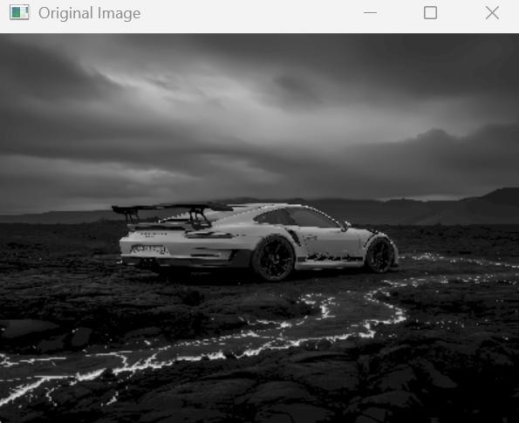
Output
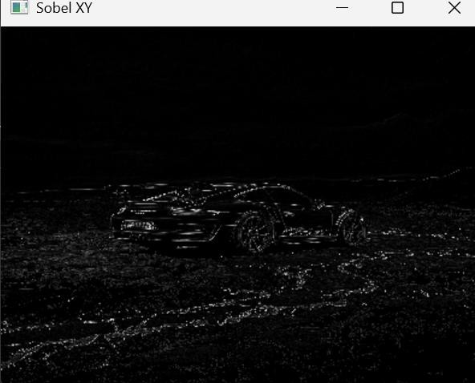

Result
Thus, the program to perform edge detection using the Sobel operator along both X and Y axes was executed successfully.

EXP 20

Aim
To sharpen an image using a Laplacian mask with a negative center coefficient.

Algorithm
- Import the OpenCV and NumPy libraries.
- Read the input image.
- Create the Laplacian kernel with a negative center coefficient.
- Apply the kernel to the image.
- Display the original and sharpened images.
- Save the sharpened image.

Code
import cv2
import numpy as np
image = cv2.imread("image1.jpg") kernel = np.array([[0, 1, 0],
[1, -4, 1],
[0, 1, 0]])
sharpened = cv2.filter2D(image, -1, kernel) display_original = cv2.resize(image, (400, 300))
display_sharpened = cv2.resize(sharpened, (400, 300)) cv2.imshow("Original Image", display_original) cv2.imshow("Sharpened Image", display_sharpened) cv2.imwrite("sharpened_image.jpg", sharpened) cv2.waitKey(0)
cv2.destroyAllWindows()

Input

Output
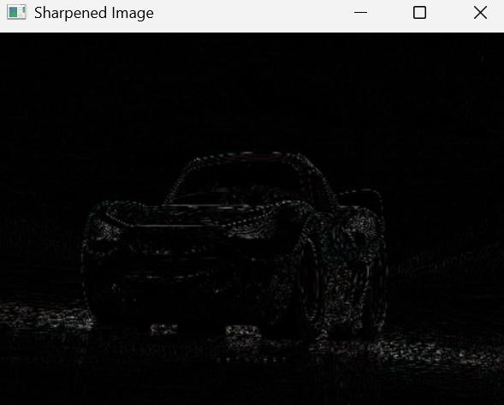

Result
Thus, the program to sharpen an image using a Laplacian mask with a negative center coefficient was executed successfully.

